# **39. DHCP (Dynamic Host Configuration Protocol)**

## **THE PURPOSE OF DHCP**

* DHCP allows hosts to **automatically** and **dynamically** learn various aspects of their network configuration **without manual/static configuration**.
* It is an **essential** part of modern networks.
  + Example: When connecting a phone or laptop to WiFi, you don't manually configure the IP address, subnet mask, or default gateway.
* Typically used for **client devices** (workstations, phones, etc.).
* **Devices such as routers and servers** are usually **manually configured**.
* In **small networks** (e.g., home networks), the **router acts as the DHCP server** for hosts in the LAN.
* In **large networks**, the **DHCP server is usually a Windows or Linux server**.

## 

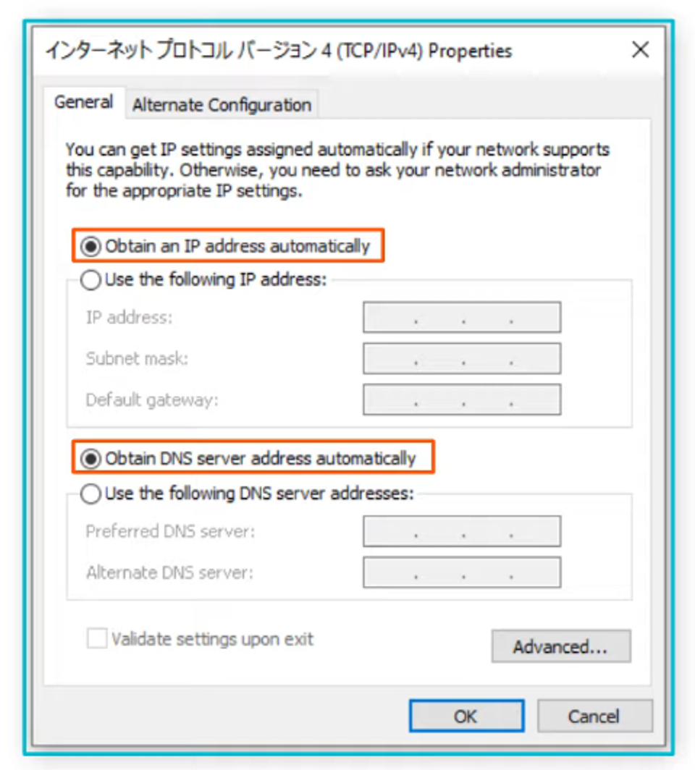

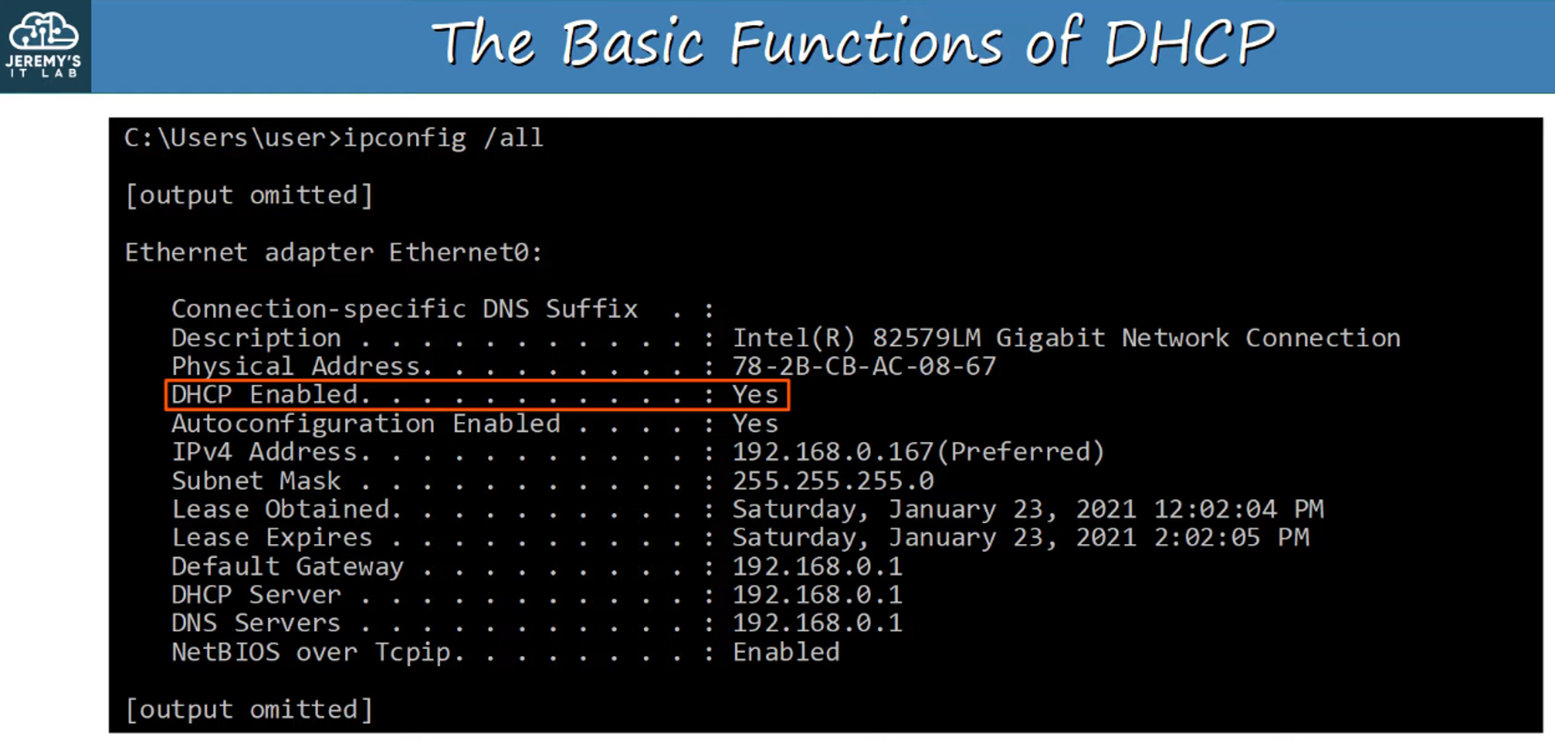

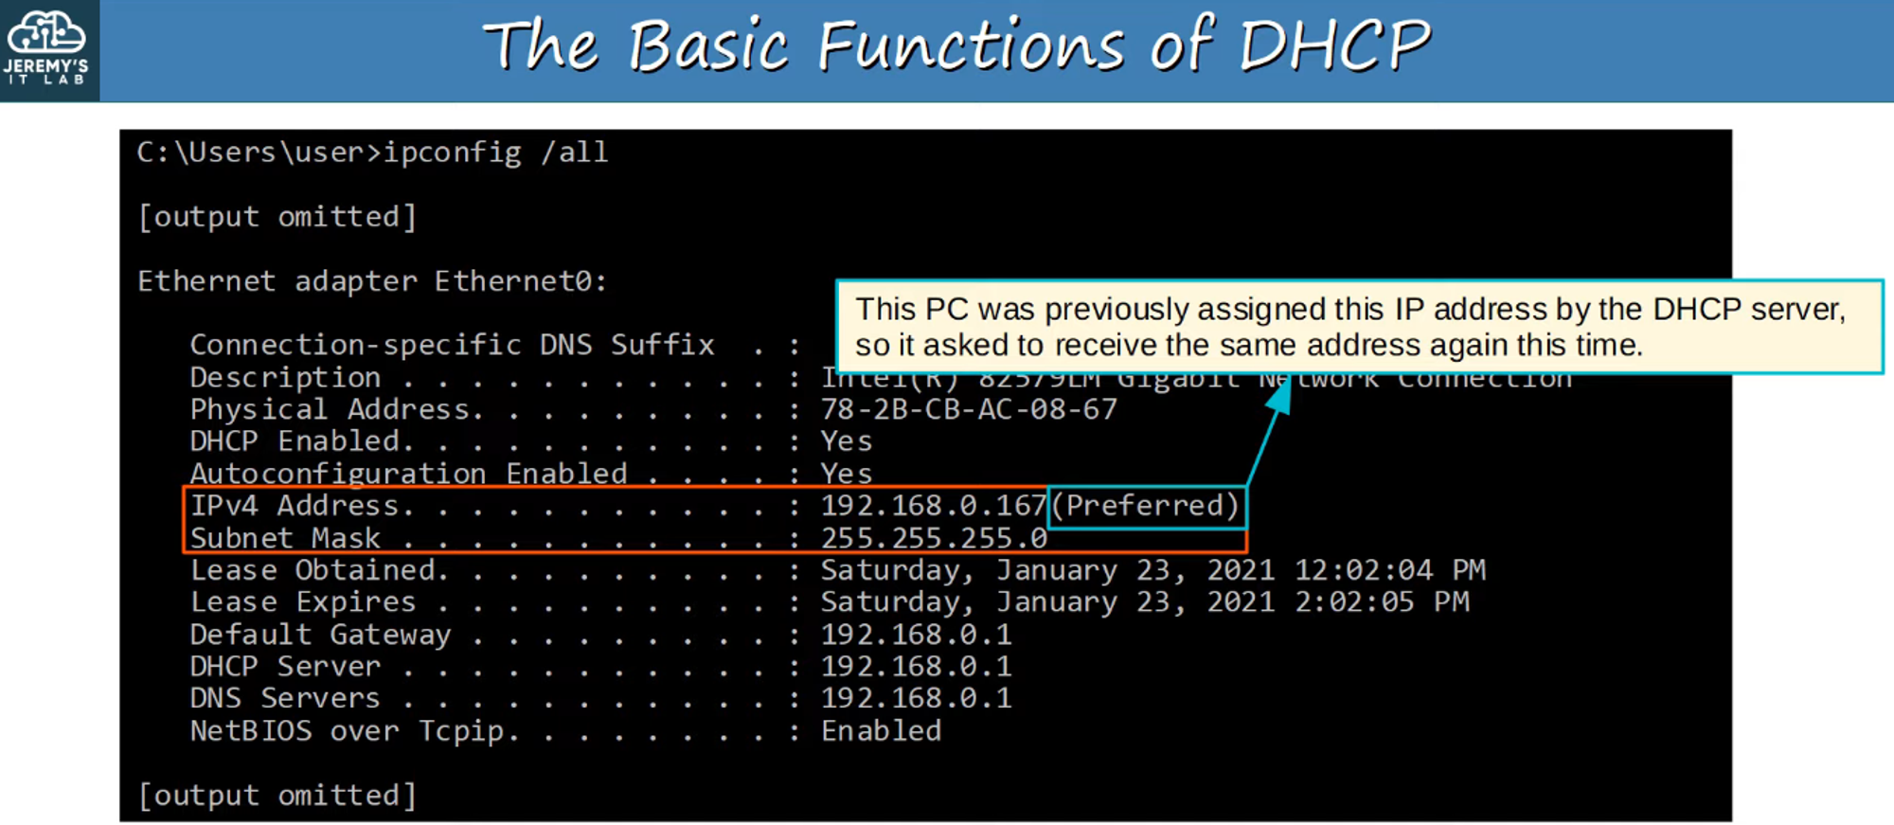

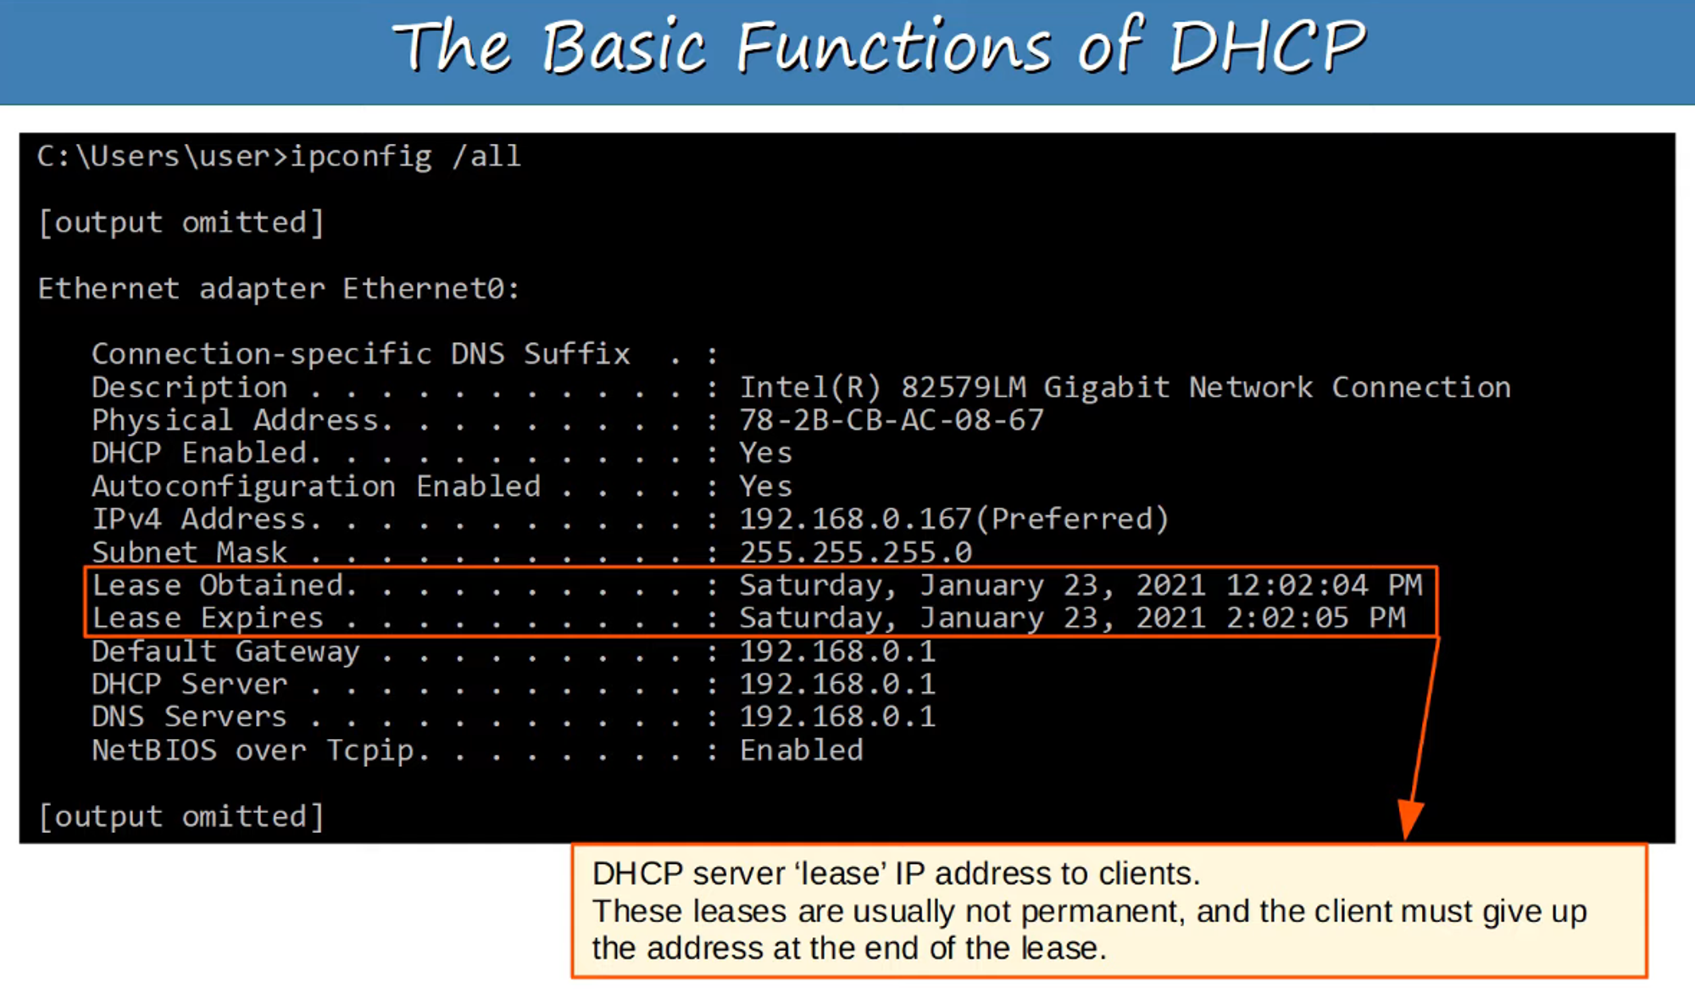

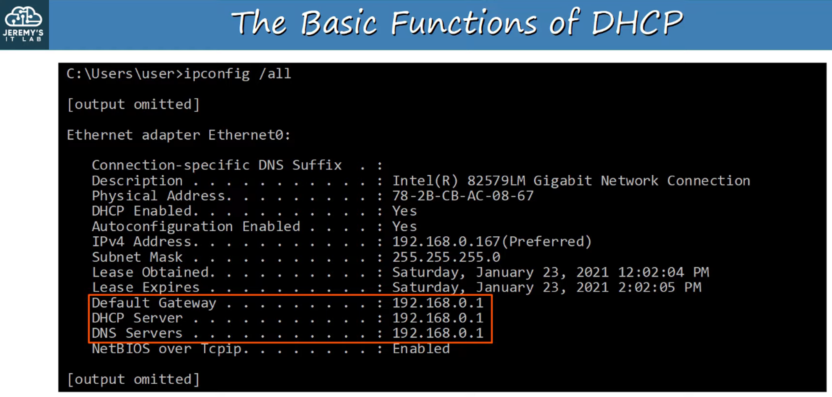

**Note:** All IPs are the same because this example uses Jeremy's home router, which provides all these services.

## **COMMAND: ipconfig /release**

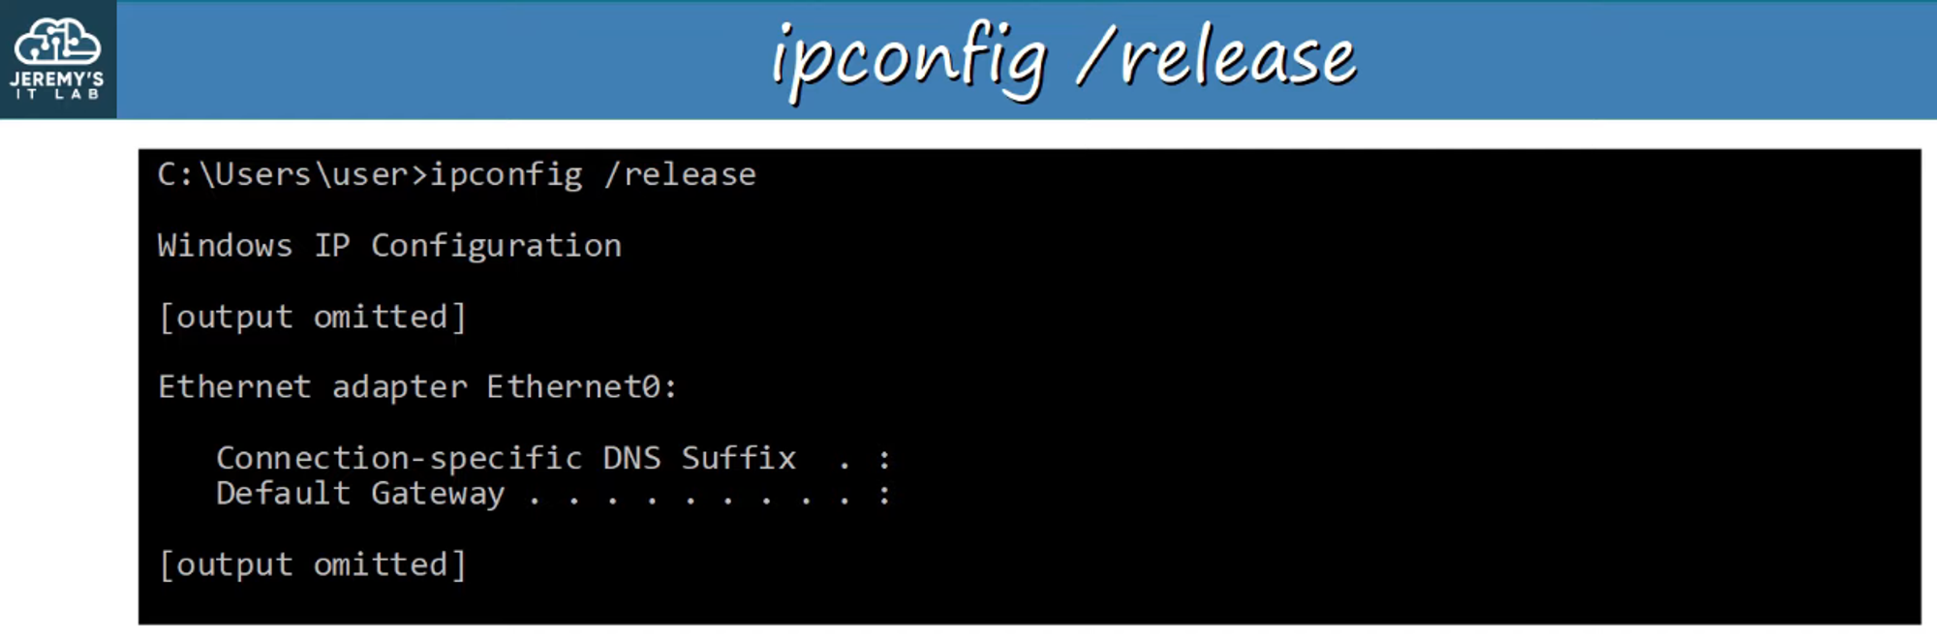

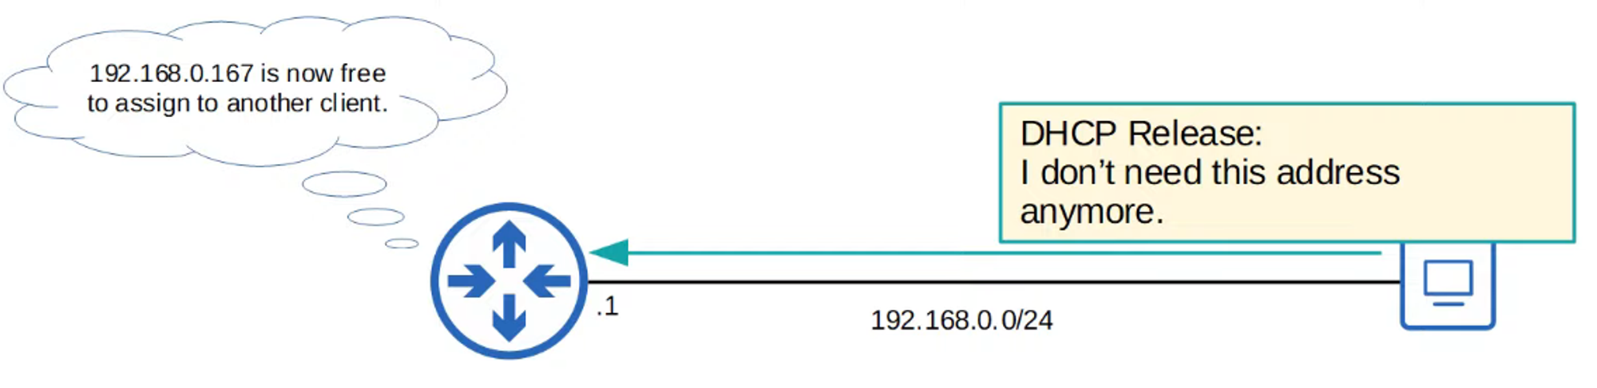

### **Wireshark Capture of ipconfig /release Mechanism**

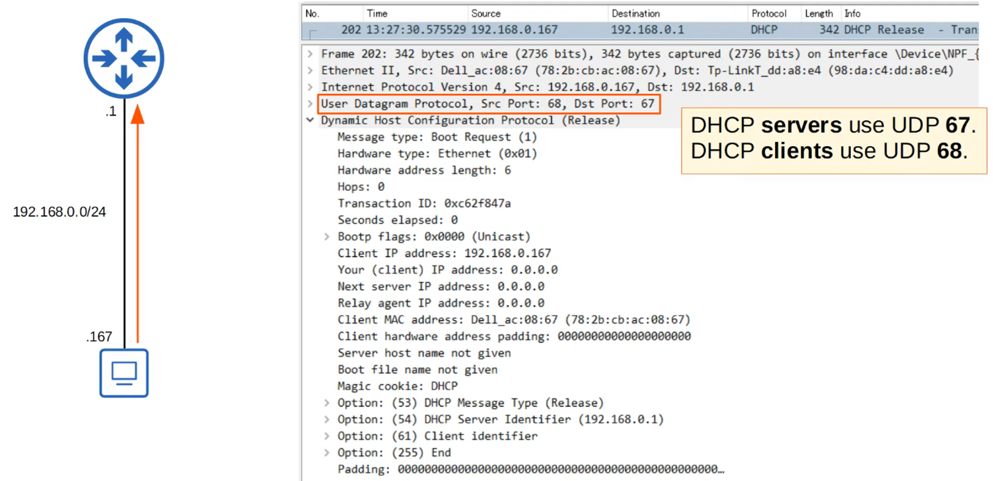

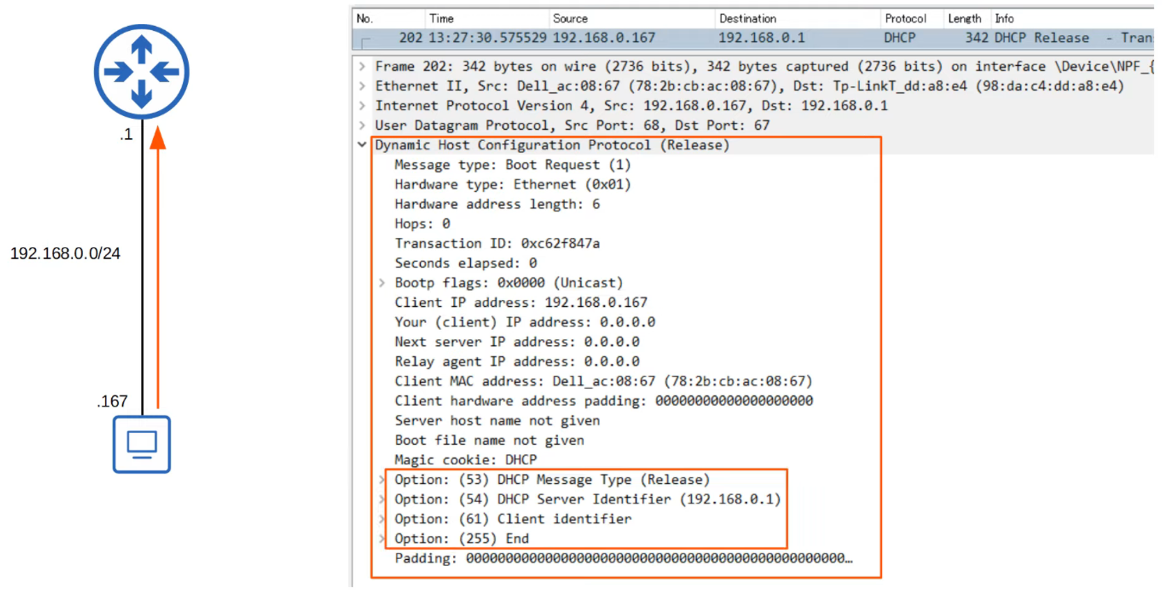

## **COMMAND: ipconfig /renew**

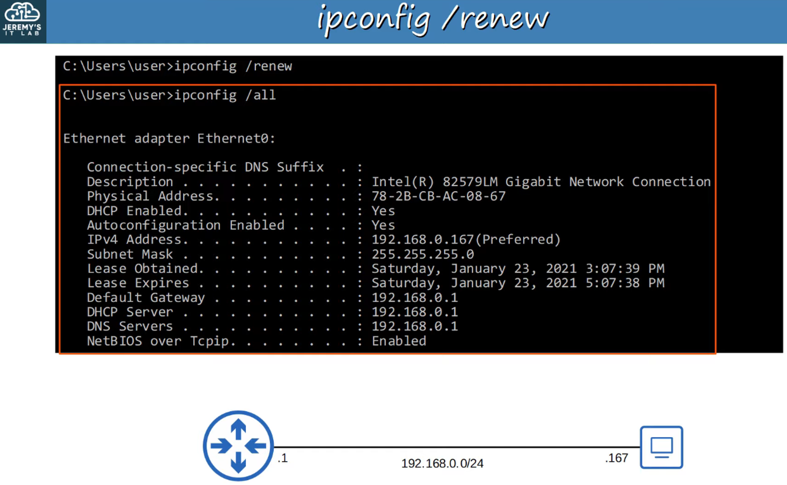

### **DHCP Renewing Process (Four Messages)**

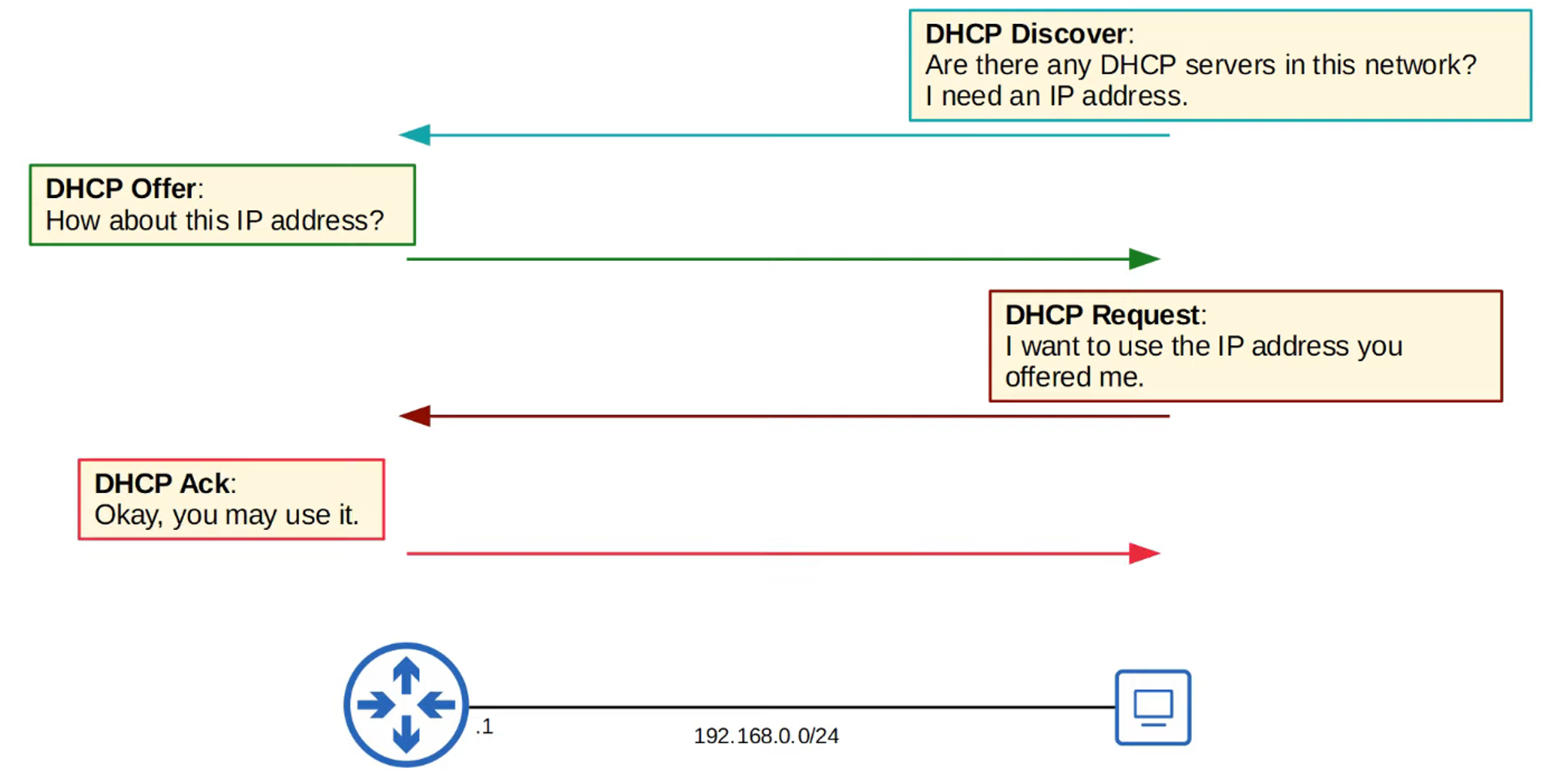

### **1) DHCP DISCOVER**

* **Client Broadcasts:** "Are there any DHCP servers in this network? I need an IP address!"

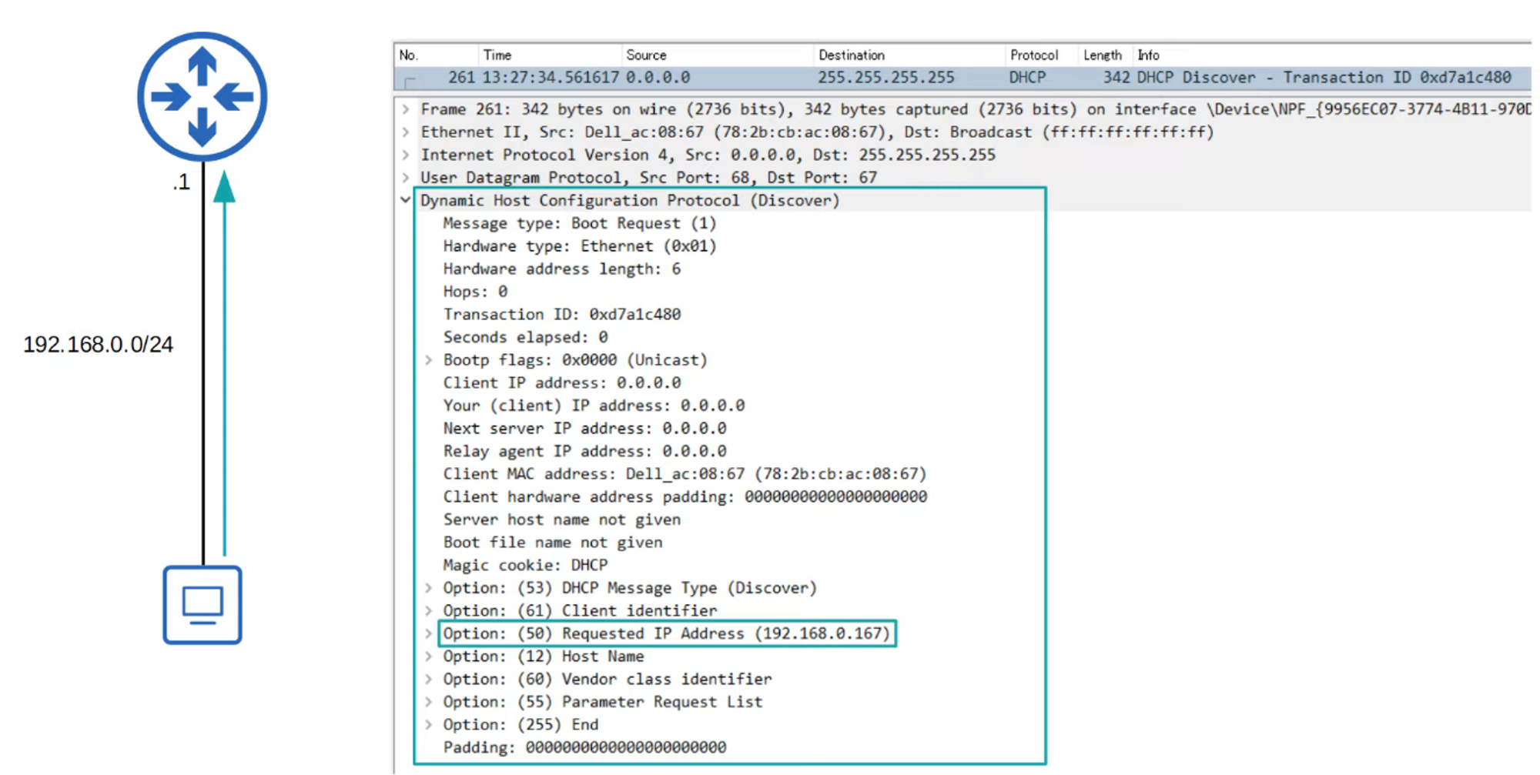

**Note:** Uses DHCP **reserved ports 67 and 68**.

### **2) DHCP OFFER**

* **DHCP Server Responds:** "How about this IP address?"

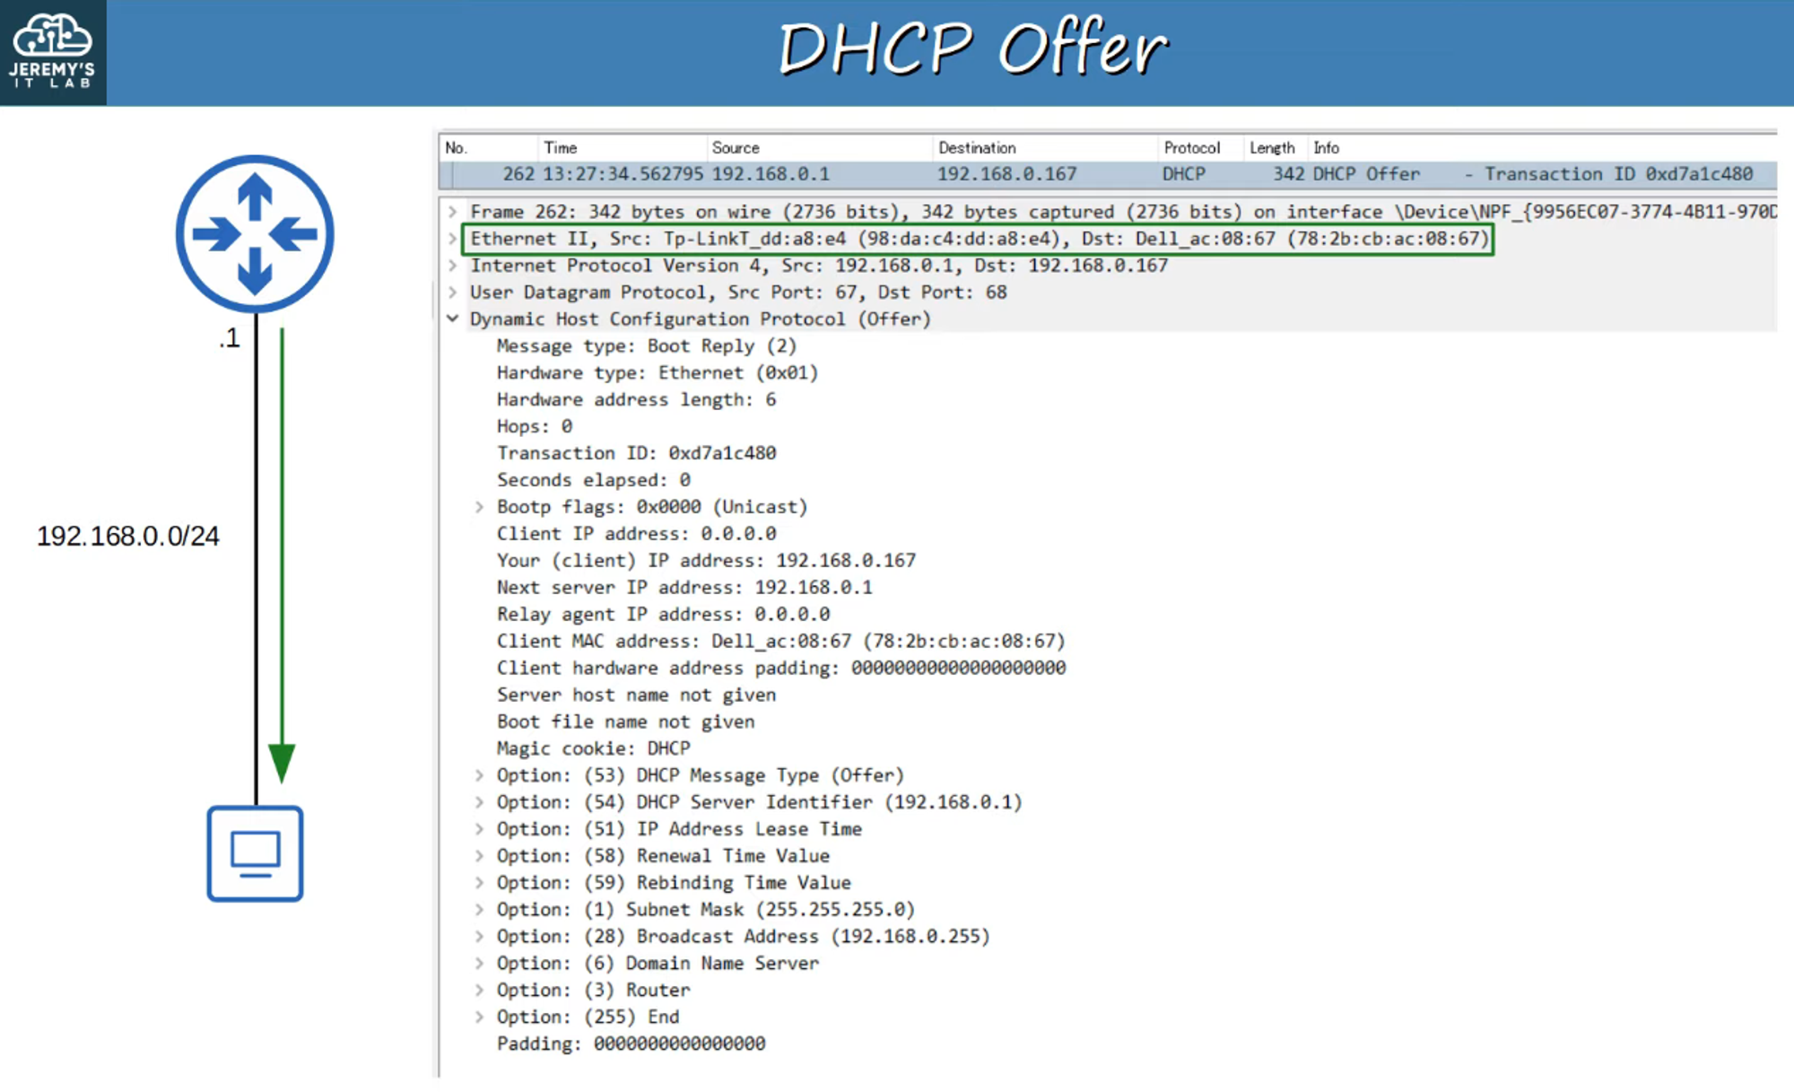

* The **DHCP offer** message can be **broadcast** or **unicast**.
* **Options include** message type, server ID, lease time, subnet, etc.

### **3) DHCP REQUEST**

* **Client Requests:** "I want to use the IP address that was offered."

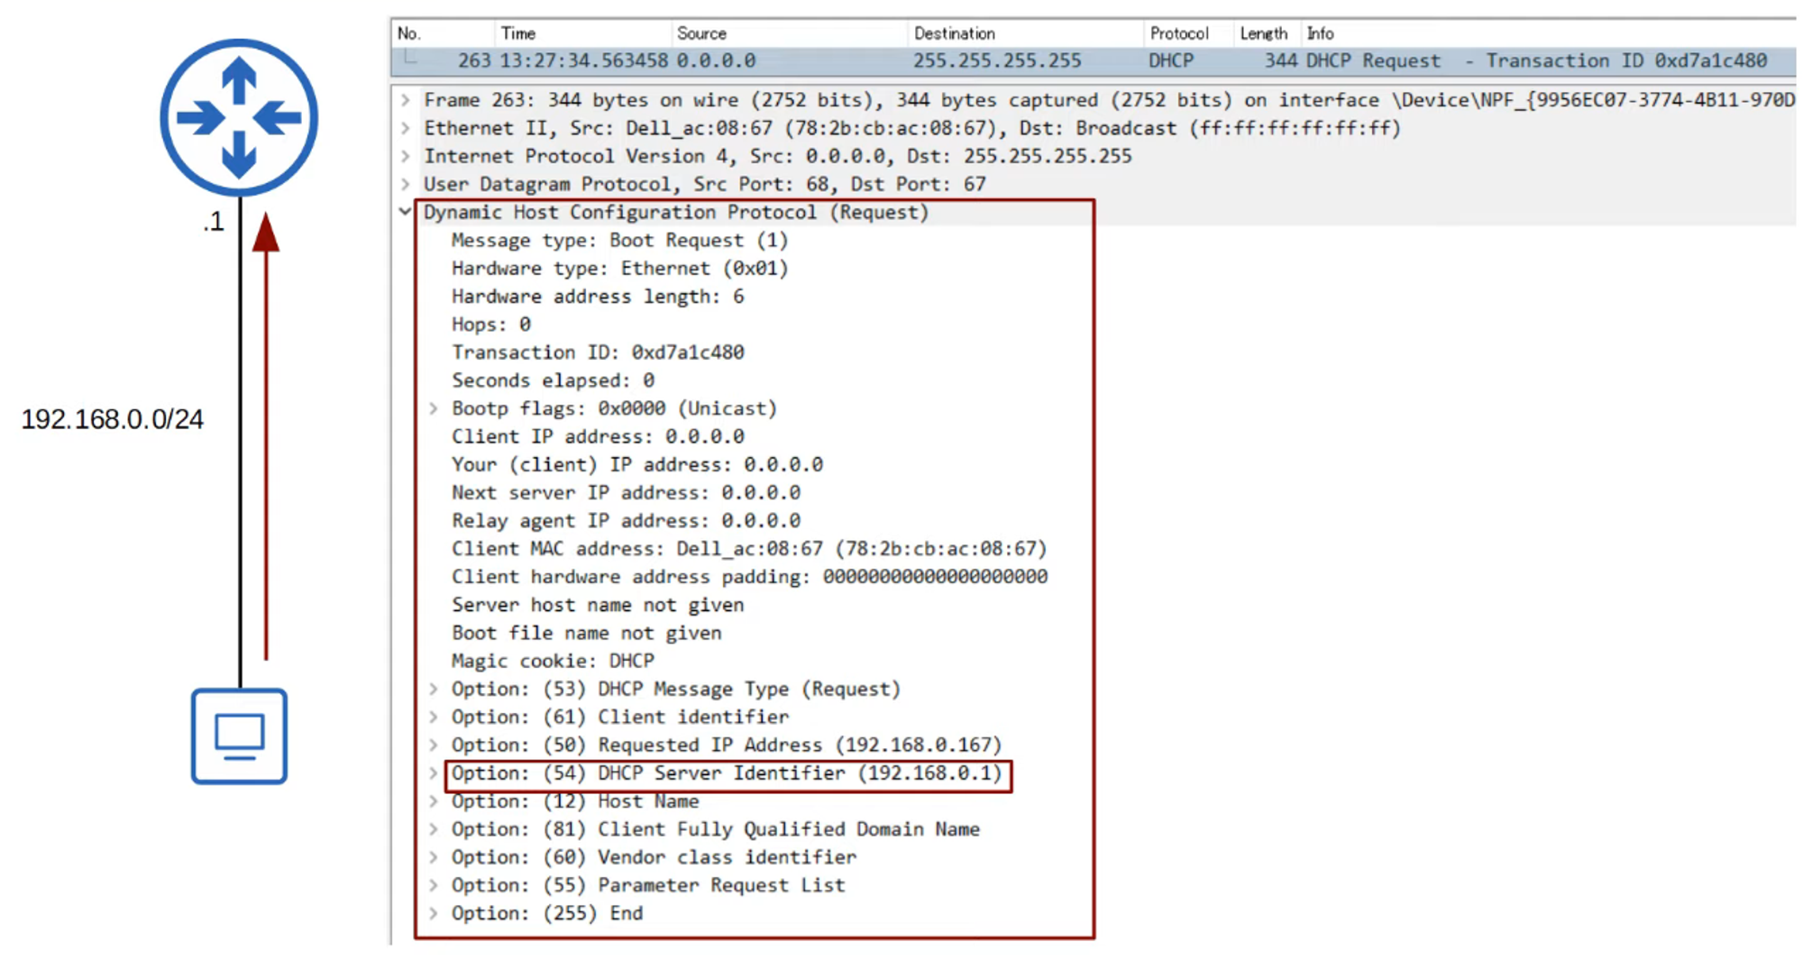

### **4) DHCP ACK**

* **DHCP Server Confirms:** "Okay! You may use that address."

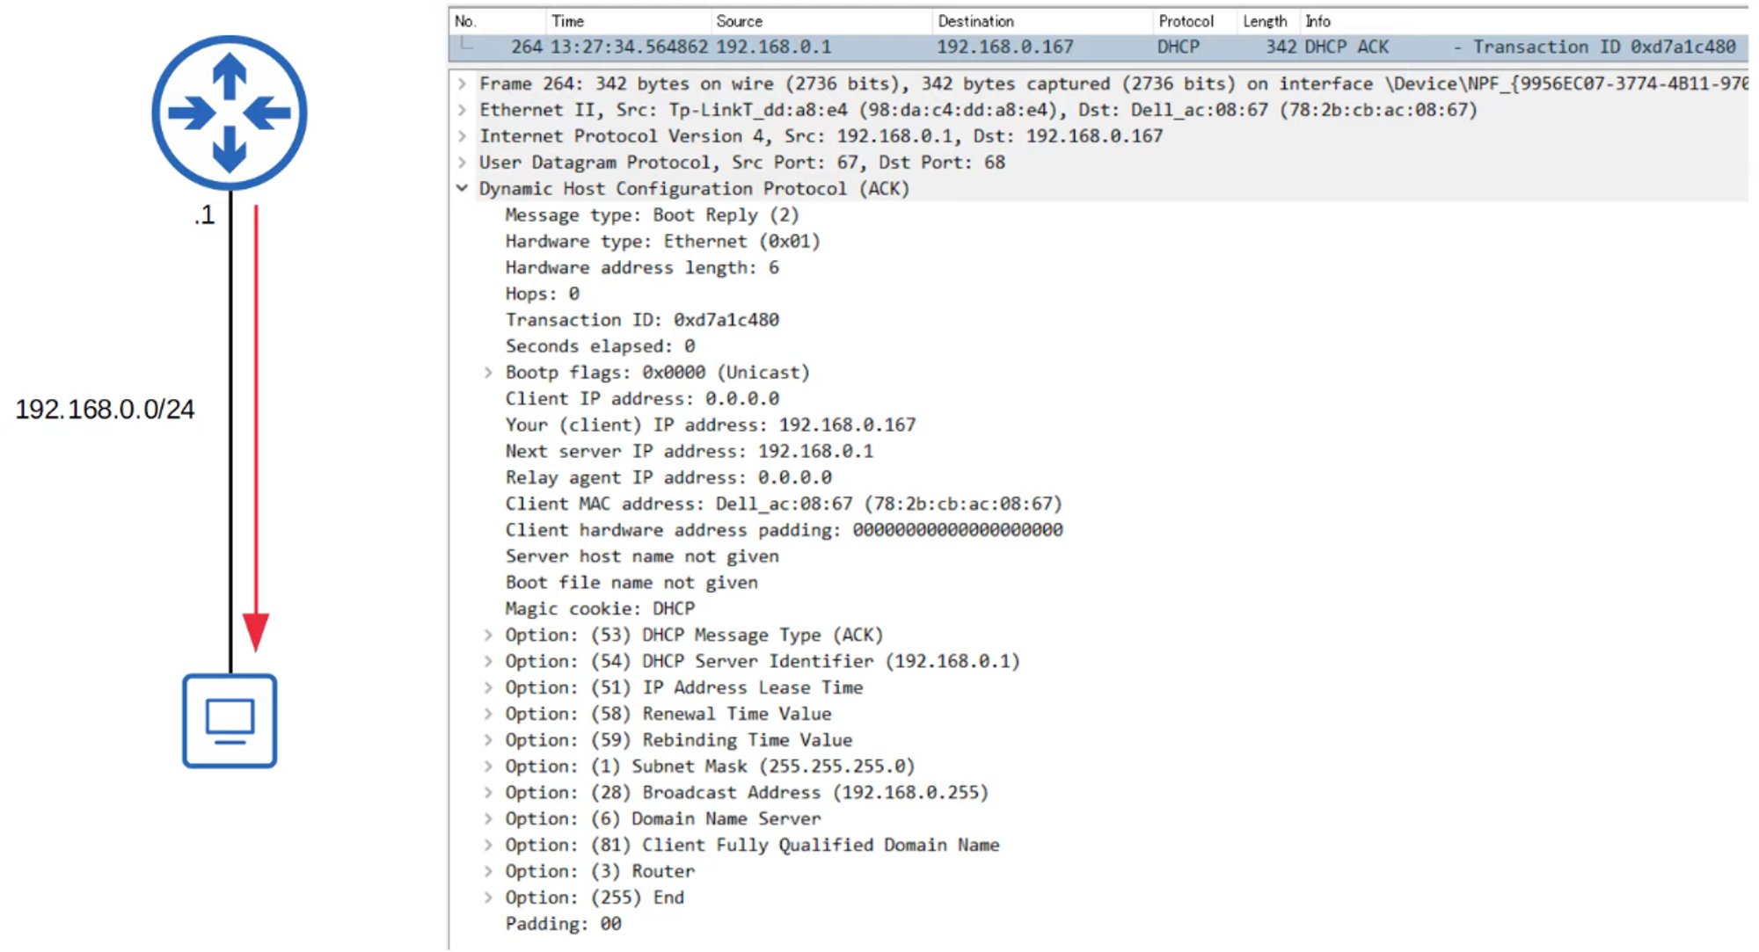

## **DHCP RENEW PROCESS SUMMARY**

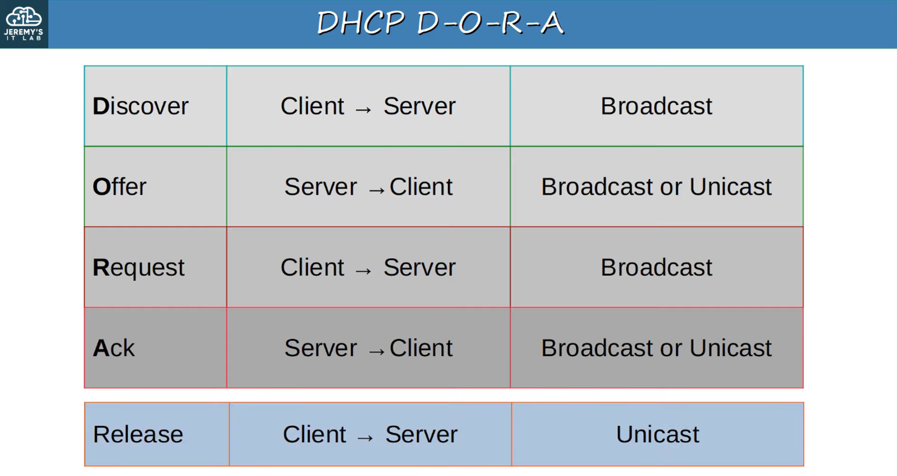

## **DHCP RELAY**

* Some network engineers configure **each router** to act as a DHCP **server** for its connected LANs.
* Large enterprises often **centralize the DHCP server**.
* **Problem:** A centralized DHCP server **won't receive broadcast DHCP messages** from clients.
* **Solution:** Configure a **router as a DHCP Relay Agent**.
  + The router **forwards broadcast DHCP messages** to the DHCP server as **unicast messages**.

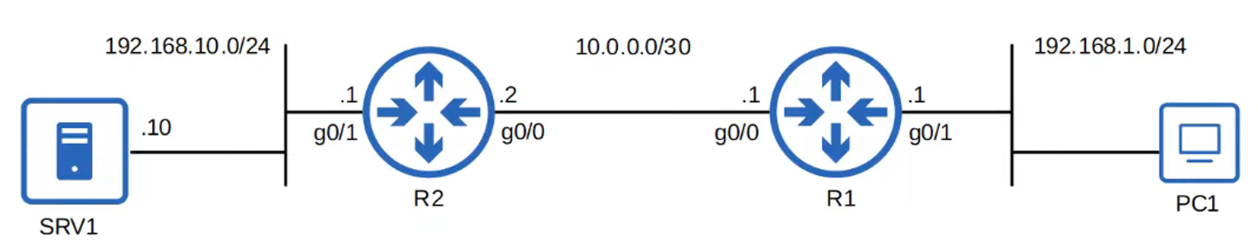

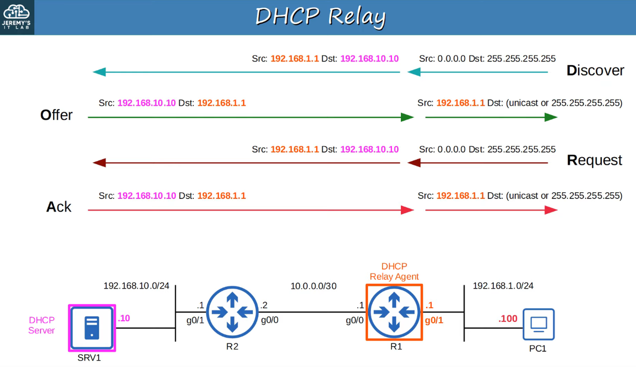

## **CONFIGURING DHCP IN CISCO IOS**

### **Commands for Configuring DHCP Servers in Cisco IOS**

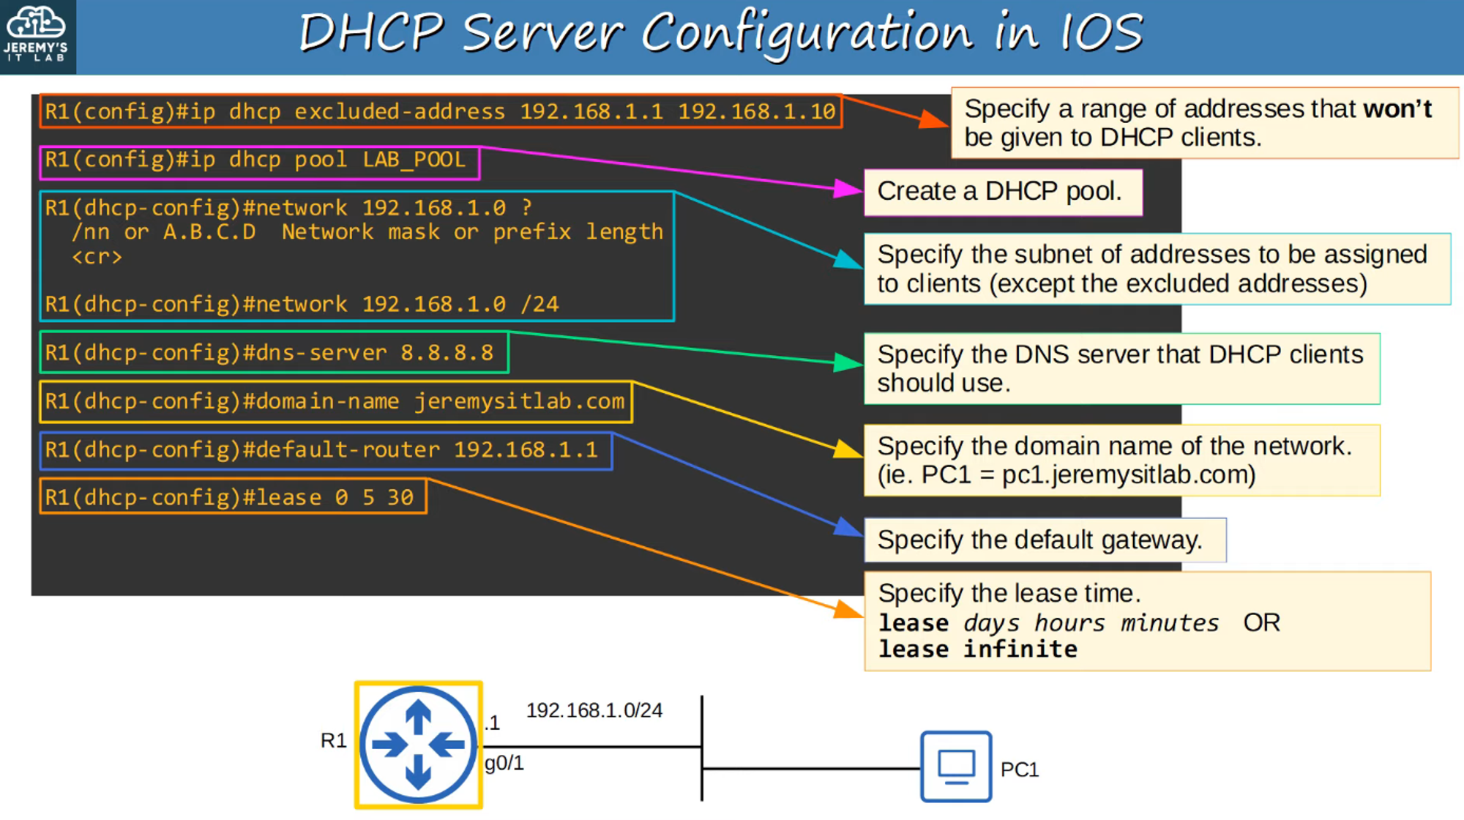

### **Command: show ip dhcp binding**

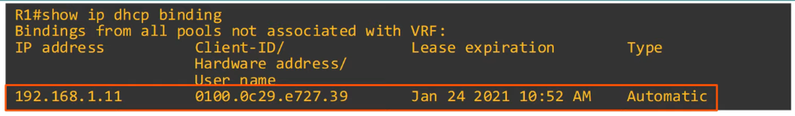

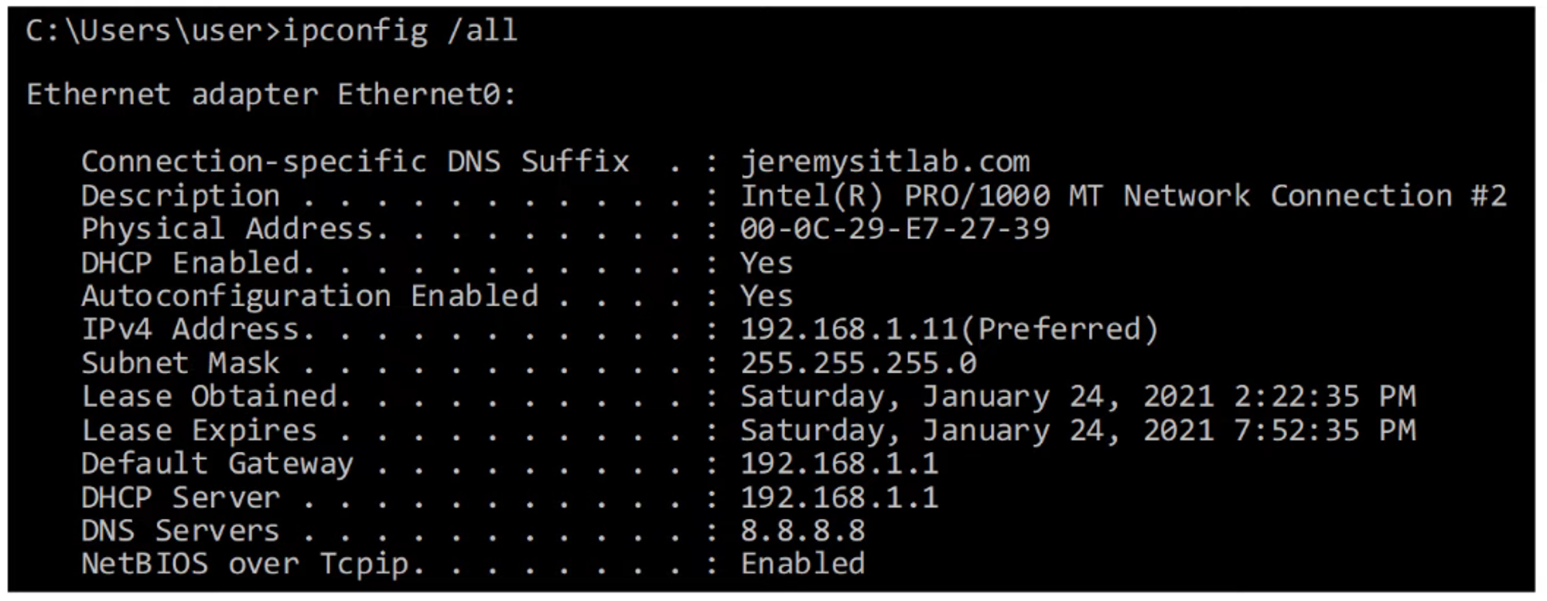

## **DHCP RELAY AGENT CONFIGURATION IN IOS**

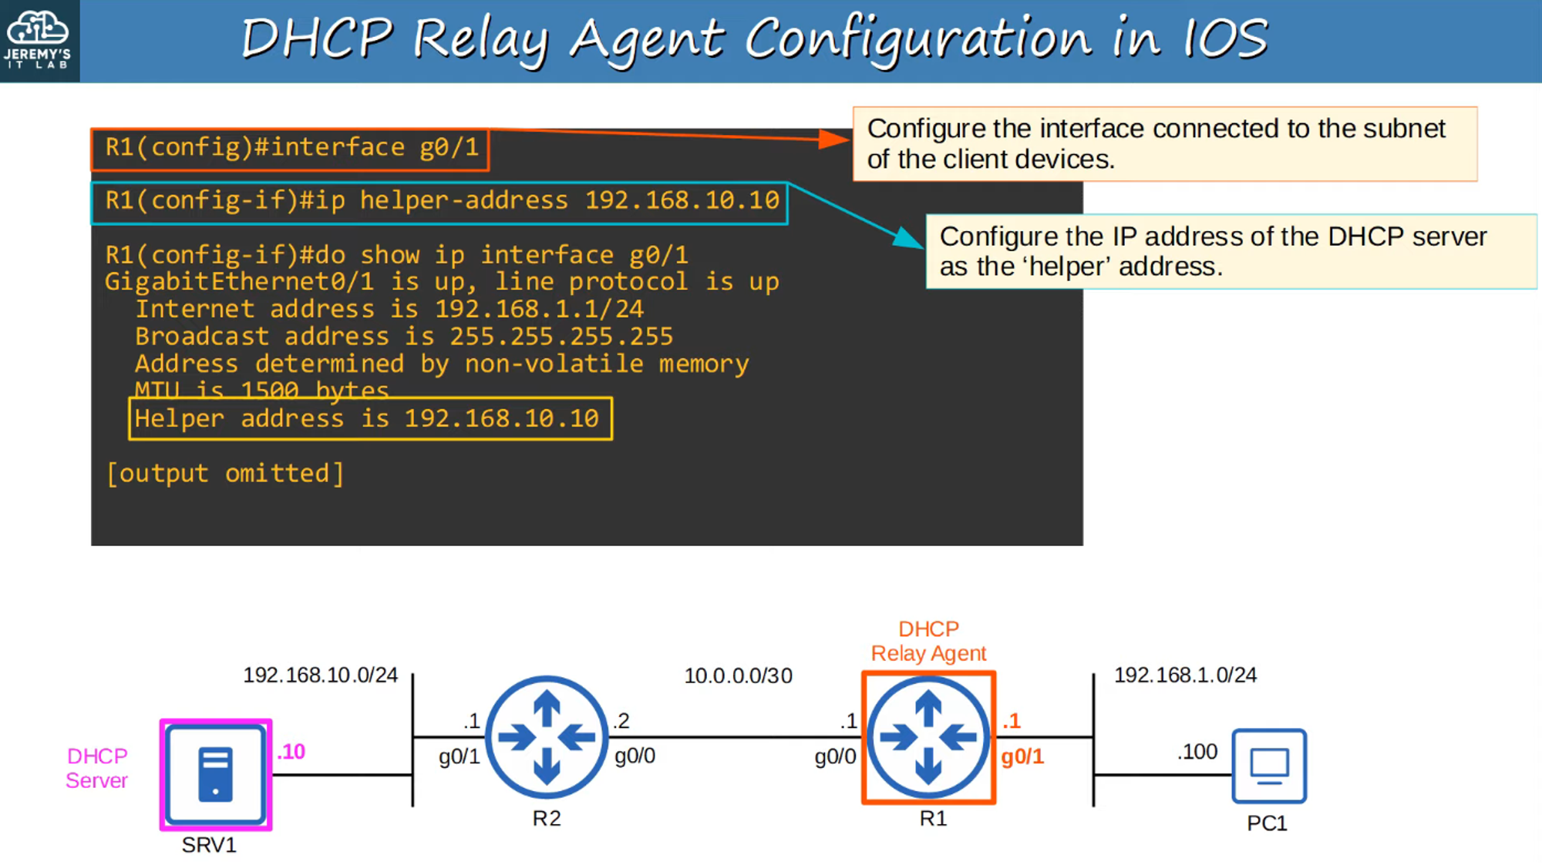

**Note:** The relay agent **must have connectivity** with the DHCP server.

## **DHCP CLIENT CONFIGURATION IN IOS**

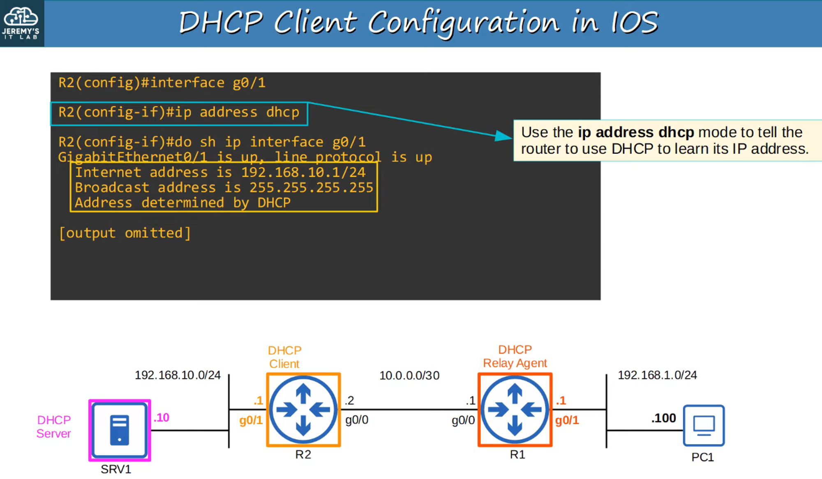

## **COMMANDS SUMMARY**

